**RIPHAH INTERNATIONAL UNIVERSITY ISLAMABAD**



**LAB #05**

**Bachelor of Computer Science – 5th Semester**

**Subject: Operating system**

**Submitted to: MS. Kausar**

**Submitted by: Eraj Shakoor**

**Sap ID: 33131**

**Q1:**

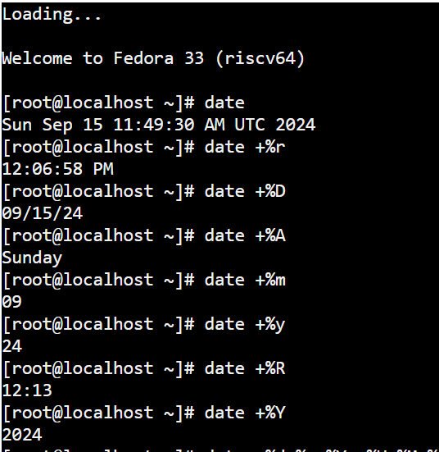

**Q2:**



**Q3:**



**Q4:**

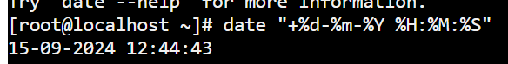

**Q5:**



**Q6:**



**Q7:**



**Q8:**

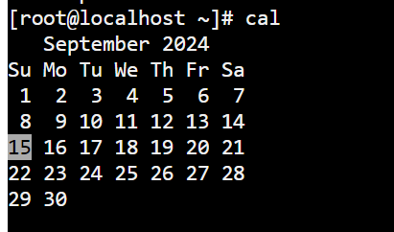

**Q9:**

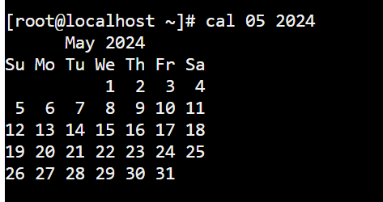

**Q10:**

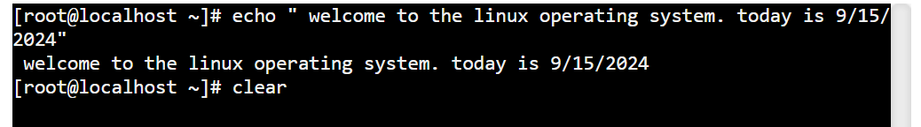

**Q11:**

